Instancia 1 de 400

MAL
Q_learning = Qlearning(instancia = instancia, proceso = proceso, episodios = 1500, epsilon = 0.01, learning_rate = 0.0001, gamma = 0.8) # lr = 0.001, gamma = 0.9 y epsilon = 0.01 # debes probar esta! epsilon = 0.1, learning_rate = 0.001, gamma = 0.85) mejora un poco pero sigue mal.
epsilon = 0.01, learning_rate = 0.0001, gamma = 0.9
epsilon = 0.01, learning_rate = 0.0001, gamma = 0.85)
epsilon = 0.01, learning_rate = 0.001, gamma = 1)
epsilon = 0.1, learning_rate = 0.001, gamma = 1
epsilon = 0.01, learning_rate = 0.01, gamma = 1)
epsilon = 0.1, learning_rate = 0.01, gamma = 1
epsilon = 0.01, learning_rate = 0.0001, gamma = 0.95
epsilon = 0.01, learning_rate = 0.0001, gamma = 0.9
epsilon = 0.01, learning_rate = 0.0001, gamma = 0.8
epsilon = 0.1, learning_rate = 0.0001, gamma = 0.8

MEJORA
epsilon = 0.01, learning_rate = 0.001, gamma = 0.85 VER SI CON 2000 MEJORA AUN MÁS
epsilon = 0.01, learning_rate = 0.001, gamma = 0.9
epsilon = 0.01, learning_rate = 0.001, gamma = 0.9)
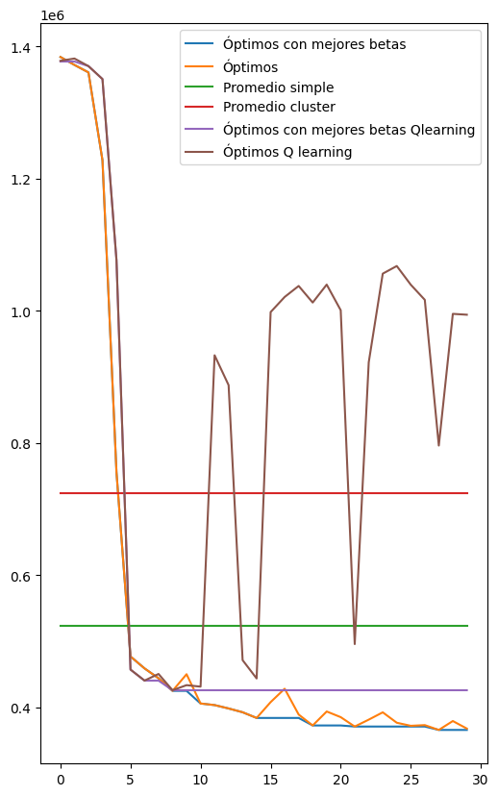epsilon = 0.01, learning_rate = 0.001, gamma = 0.9

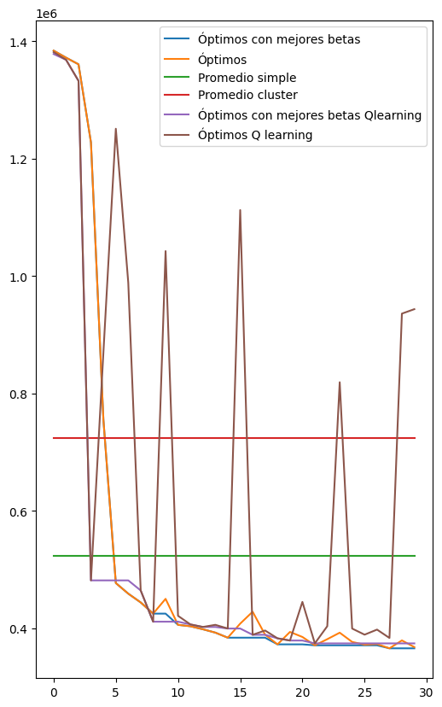 epsilon = 0.05, learning_rate = 0.001, gamma = 0.9

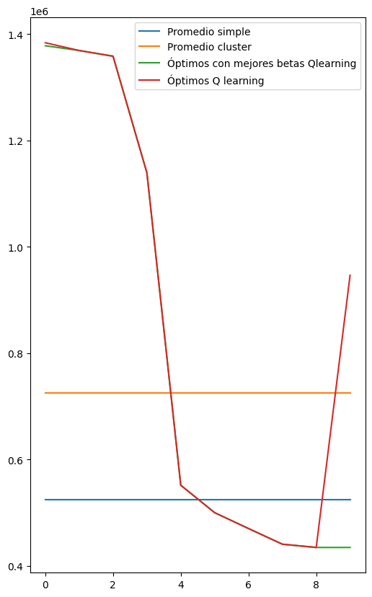 epsilon = 0.01, learning_rate = 0.001, gamma = 0.85
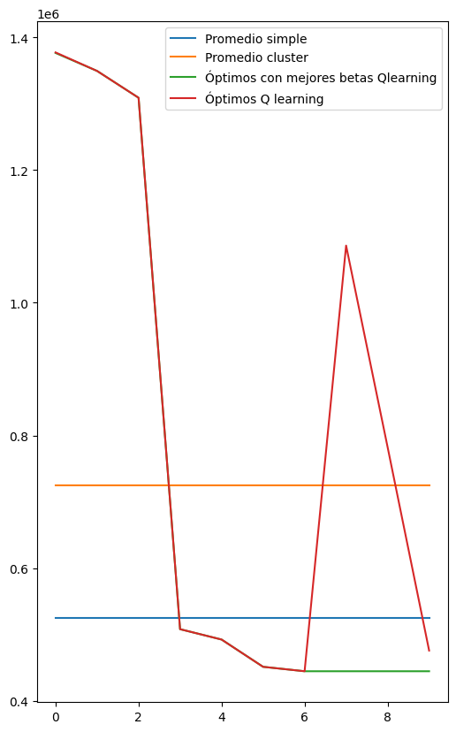 epsilon = 0.05, learning_rate = 0.001, gamma = 0.9
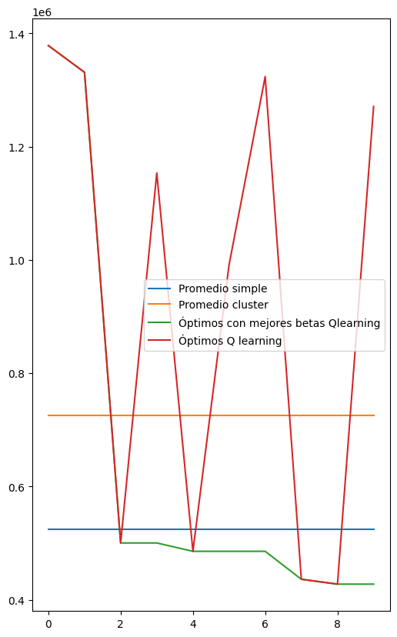 epsilon = 0.1, learning_rate = 0.001, gamma = 0.9

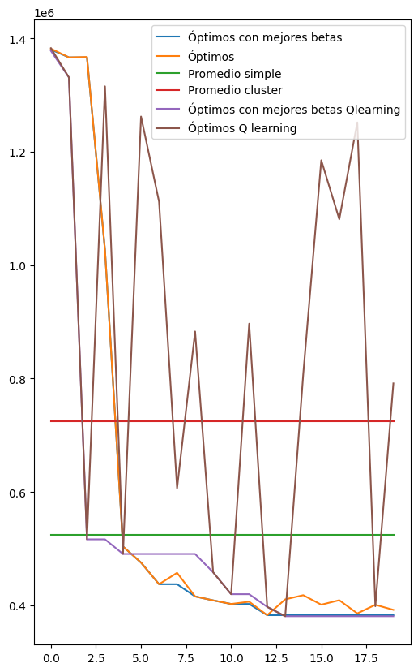 epsilon = 0.1, learning_rate = 0.001, gamma = 0.9)
epsilon=0.15, learning_rate=0.0001MC
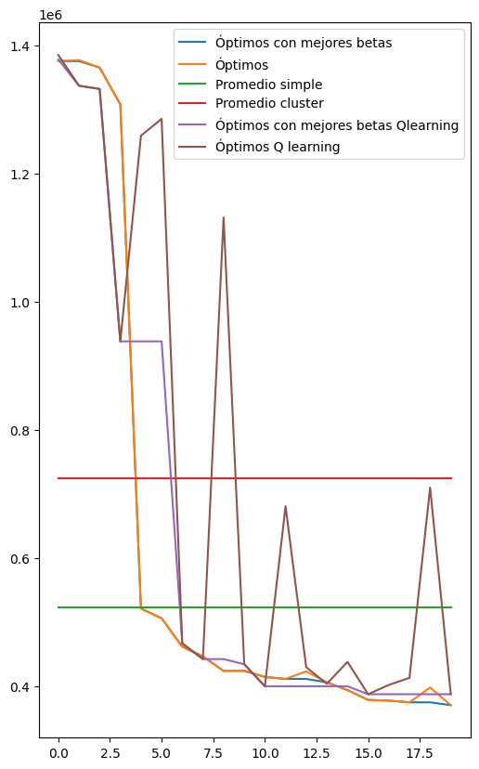 epsilon = 0.05, learning_rate = 0.001, gamma = 0.9
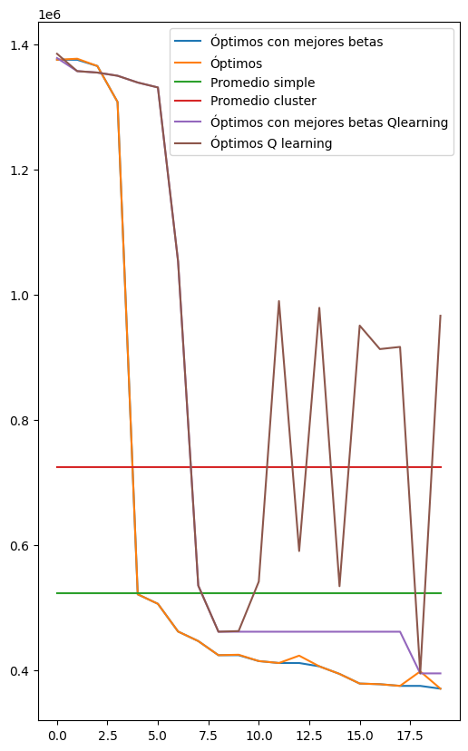epsilon = 0.01, learning_rate = 0.001, gamma = 0.9
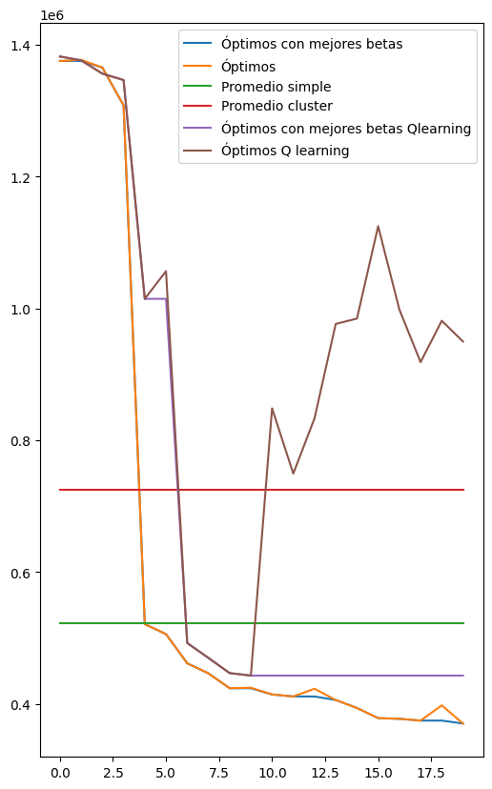 epsilon = 0.01, learning_rate = 0.001, gamma = 0.85
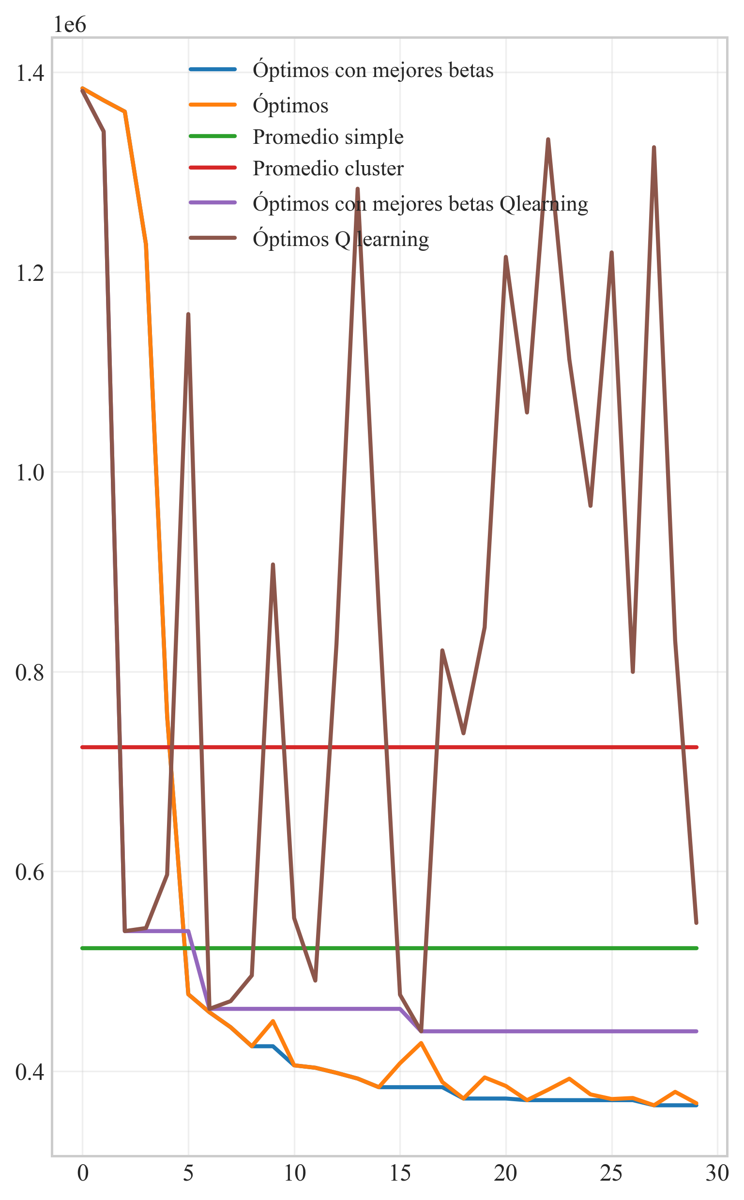epsilon = 0.05, learning_rate = 0.001, gamma = 0.85

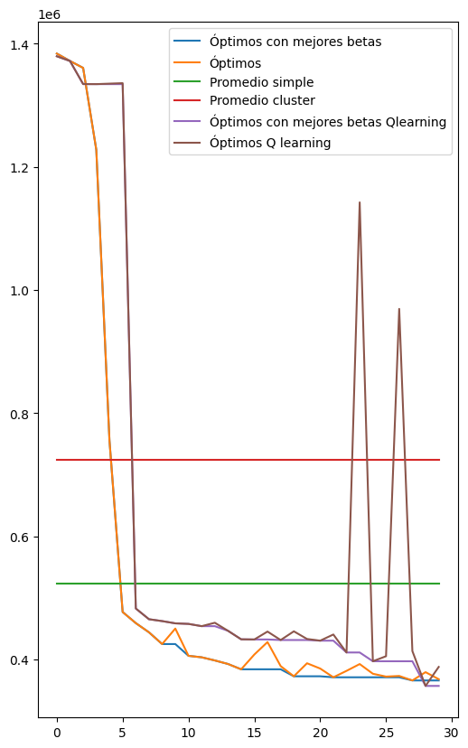epsilon = 0.05, learning_rate = 0.001, gamma = 0.95

